APPLIED PHYSICS LAB REPORT

Name: BILAL ABID ABBASI

Reg No: 45961

Experiment 1: Measurements using Vernier Caliper

Objective
To measure the diameter and length of an object using a Vernier Caliper.
Apparatus
Vernier Caliper, metal rod/sphere

Theory
A Vernier Caliper is used for accurate measurement of internal, external diameters and depth.
Least Count = 1 MSD – 1 VSD = 0.01 cm

Procedure
- Clean the jaws of the Vernier Caliper.
- Place the object between jaws.
- Note the main scale reading.
- Note Vernier scale coincidence.
- Calculate final reading.

Observation Table
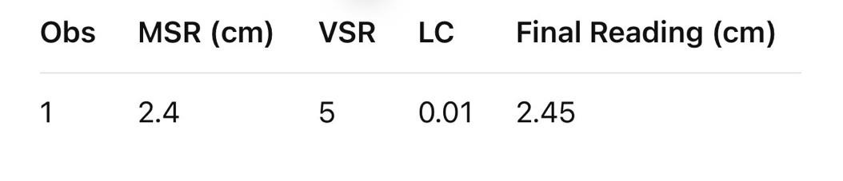

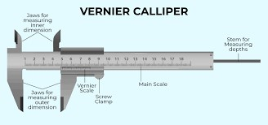
Diagram

Result
The diameter of the object was measured accurately.

Precautions
- Avoid zero error
- Hold instrument gently

Experiment 2: Measurements using Screw Gauge

Objective
To measure thickness of a wire using screw gauge.
Apparatus
Screw Gauge, wire

Theory
Least Count = Pitch / No. of divisions
= 1 mm / 100 = 0.01 mm

Procedure
- Place wire between spindle and anvil.
- Rotate thimble till contact.
- Note pitch scale and circular scale.
- Calculate thickness.

Observation Table


Diagram
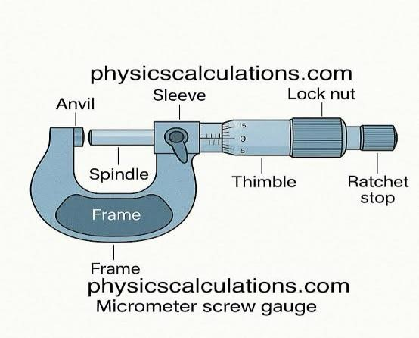

Result

Thickness of wire was found correctly.

Precautions
- Avoid over-tightening
- Check zero error

Experiment 3: Time Period of Simple Pendulum
Objective
To find time period of a simple pendulum.

Theory
Time Period:
T = 2π√(L/g)

Procedure
- Suspend bob with string.
- Displace slightly and release.
- Measure time for 20 oscillations.
- Calculate time period.

Observation Table
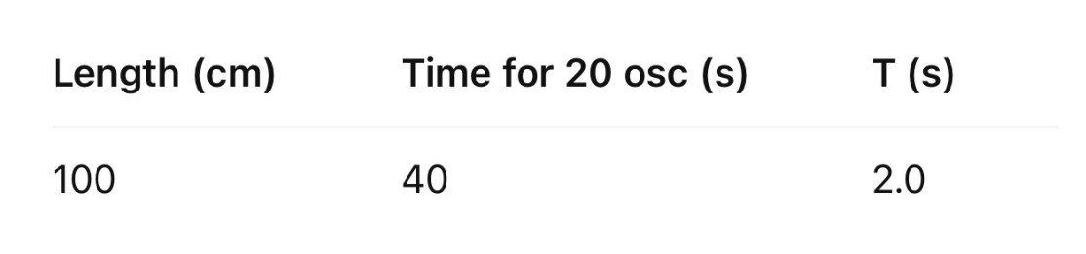

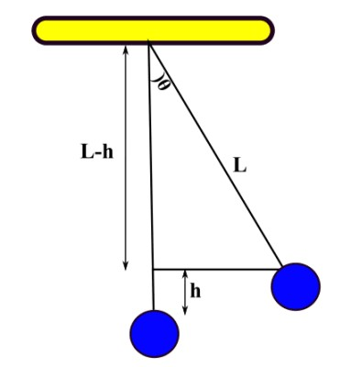
Diagram

Result
Time period calculated successfully.

Experiment 4: Length of Seconds Pendulum

Objective
To find length of a seconds pendulum.
Theory
For seconds pendulum: T = 2 s
Result Formula
L = gT² / 4π²

Observation Table


Diagram
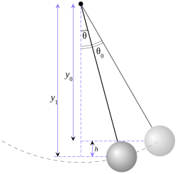

Result

Length of seconds pendulum ≈ 99 cm

Experiment 5: Resistance by Color Coding

Objective
To determine resistance using color bands.
Theory
Color code gives resistance value.

Observation Table

Result
Resistance found using color code.

Diagram
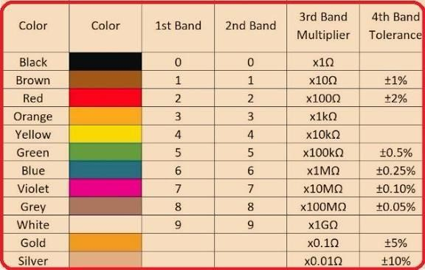

Experiment 6: Digital Multimeter

Objective
To measure voltage, current, resistance using DMM.

Observation Table
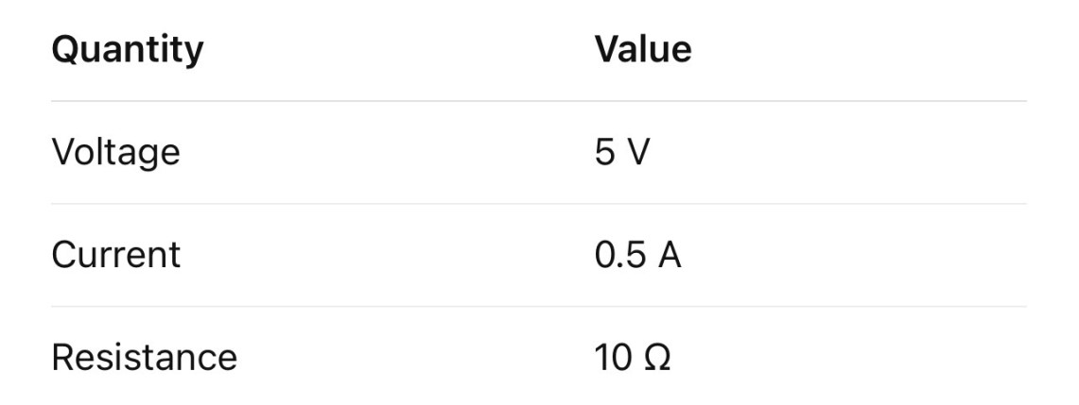

Result
Electrical quantities measured successfully.

Diagram
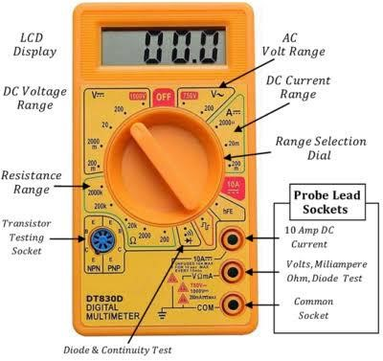

Experiment 7: Rheostat Resistance

Objective
To find resistance of a rheostat.
Theory
Ohm’s Law: V = IR

Table

Result
Resistance calculated.

Diagram
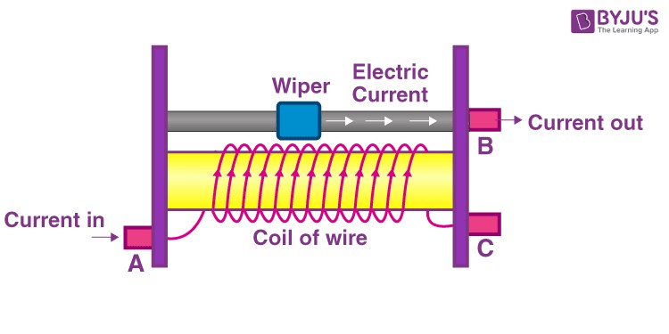

Experiment 8: Series & Parallel Resistors

Theory
Series: Rs = R1 + R2
Parallel: 1/Rp = 1/R1 + 1/R2

Diagram
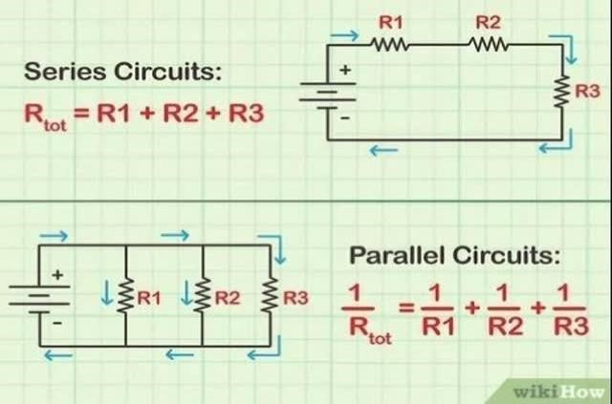

Result
Series and parallel circuits verified.

Experiment 9: Series & Parallel Capacitors

Theory
Series: 1/C = 1/C1 + 1/C2
Parallel: C = C1 + C2
Result
Capacitor combinations verified.

Diagram
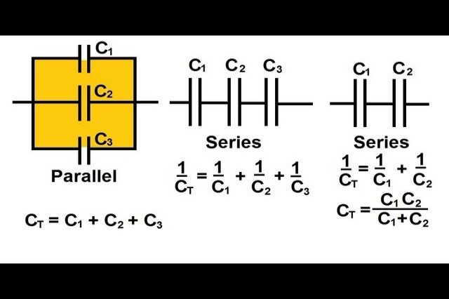

Experiment 10: RC Time Constant

Objective
To determine RC time constant. Theory
τ = RC

Table
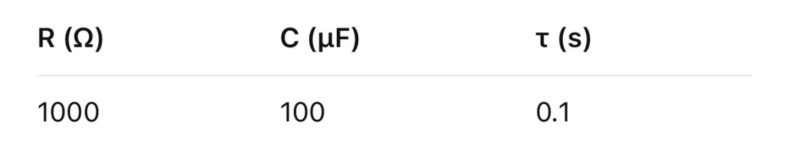
Result
RC time constant calculated.

Diagram
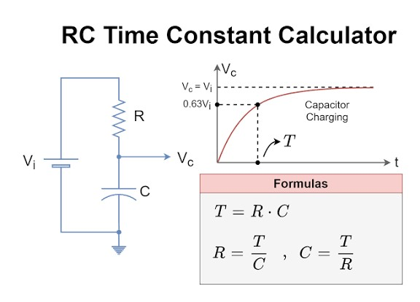

Experiment 11: Diode Characteristics

Objective
To study V-I characteristics of diode.
Graph
Forward & Reverse bias V-I curve.

Result
Knee voltage observed.

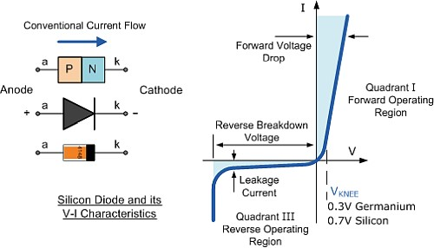
Diagram

Experiment 12: Analog Oscilloscope

Objective
To understand CRO.

Result
Waveforms observed and calibrated.
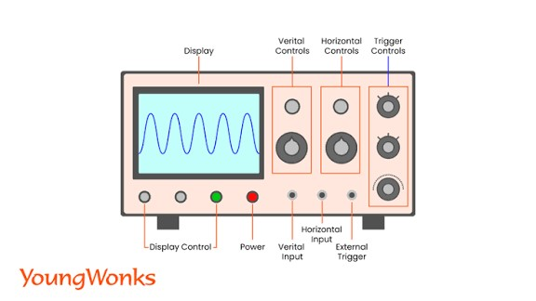
Diagram

Experiment 13: Galvanometer to Voltmeter
Theory
High resistance connected in series.
Result
Galvanometer converted to voltmeter.

Diagram
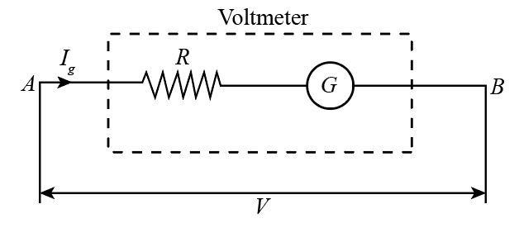

Experiment 14: Galvanometer to Ammeter

Theory
Low resistance connected in parallel. Result
Galvanometer converted to ammeter.

Diagram
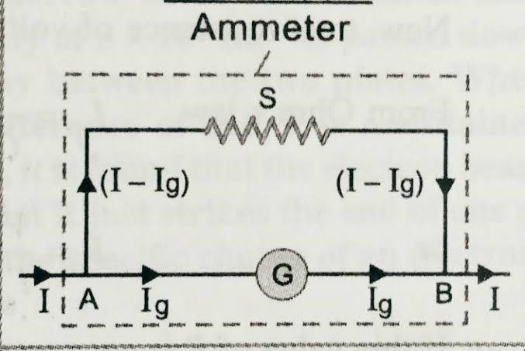

NUMERICAL CALCULATIONS

Experiment 1: Vernier Caliper

Given
- Least Count (LC) = 0.01 cm
- Main Scale Reading (MSR) = 2.4 cm
- Vernier Scale Coincidence (VSR) = 5

Formula

Final Reading = MSR + (VSR × LC)

Calculation

= 2.4 + (5 × 0.01)
= 2.4 + 0.05
= 2.45 cm

Result

Diameter of object = 2.45 cm

Experiment 2: Screw Gauge

Given
- Pitch = 1 mm
- Circular scale divisions = 100
- LC = 1/100 = 0.01 mm
- PSR = 0.5 mm
- CSR = 20

Formula

Thickness = PSR + (CSR × LC)

Calculation

= 0.5 + (20 × 0.01)
= 0.5 + 0.2
= 0.7 mm

Result

Thickness of wire = 0.7 mm

Experiment 3: Simple Pendulum

Given
- Length (L) = 1 m
- Time for 20 oscillations = 40 s

Formula

Time Period (T) = Total Time / No. of Oscillations

Calculation

T = 40 / 20
T = 2 s

Result

Time period of pendulum = 2 s

Experiment 4: Seconds Pendulum

Given
- T = 2 s
- g = 9.8 m/s²

Formula

L = \frac{gT^2}{4\pi^2}

Calculation

L = \frac{9.8 × (2)^2}{4 × (3.14)^2}

L = \frac{39.2}{39.48}

L ≈ 0.993 m = 99.3 cm

Result

Length of seconds pendulum ≈ 99.3 cm

Experiment 5: Resistance by Color Code

Given

Color bands: Brown – Black – Red

Values
- Brown = 1
- Black = 0
- Red = ×10²

Calculation

Resistance = 10 × 10²
= 1000 Ω = 1 kΩ

Result

Resistance of resistor = 1 kΩ

Experiment 6: Digital Multimeter

Observed
- Voltage = 5 V
- Current = 0.5 A

Formula (Ohm’s Law)

R = \frac{V}{I}

Calculation

R = \frac{5}{0.5} = 10 Ω

Result

Resistance = 10 Ω

Experiment 7: Rheostat Resistance

Given
- Voltage = 6 V
- Current = 0.3 A

Formula

R = \frac{V}{I}

Calculation
R = \frac{6}{0.3} = 20 Ω

Result

Resistance of rheostat = 20 Ω

Experiment 8: Series & Parallel Resistors

Given
- R₁ = 10 Ω
- R₂ = 20 Ω

Series

Rs = R₁ + R₂
Rs = 10 + 20 = 30 Ω

Parallel

\frac{1}{Rp} = \frac{1}{10} + \frac{1}{20}

Rp = 6.67 Ω

Result
Series = 30 Ω, Parallel = 6.67 Ω

Experiment 9: Series & Parallel Capacitors

Given
- C₁ = 10 µF
- C₂ = 20 µF

Parallel

C = C₁ + C₂
C = 30 µF

Series

\frac{1}{C} = \frac{1}{10} + \frac{1}{20}

C = 6.67 µF

Result

Parallel = 30 µF, Series = 6.67 µF

Experiment 10: RC Time Constant

Given
- R = 1000 Ω
- C = 100 µF = 100 × 10⁻⁶ F

Formula

\tau = RC

Calculation

\tau = 1000 × 100 × 10^{-6}

\tau = 0.1 s

Result

RC time constant = 0.1 s

Experiment 11: Diode Characteristics

Given
• Forward voltage ≈ 0.7 V

Result
Knee voltage of silicon diode ≈ 0.7 V

Experiment 12: CRO

Given
- Time/div = 2 ms
- No. of divisions = 5

Calculation

Time = 2 × 5 = 10 ms

Experiment 13: Galvanometer → Voltmeter

Given
- Ig = 1 mA
- G = 50 Ω
- V = 10 V

Formula

R = \frac{V}{Ig} - G

Calculation

R = \frac {10}{0.001} - 50

R = 9950 Ω

Experiment 14: Galvanometer → Ammeter

Given
- I = 1 A
- Ig = 0.001 A
- G = 50 Ω

Formula

S = \frac {Ig × G}{I - Ig}

Calculation

S = \frac {0.001 × 50}{1 - 0.001}

S ≈ 0.05 Ω

